TYPE : GIMBAL

METALLIC GIMBAL EXPANSION JOINT
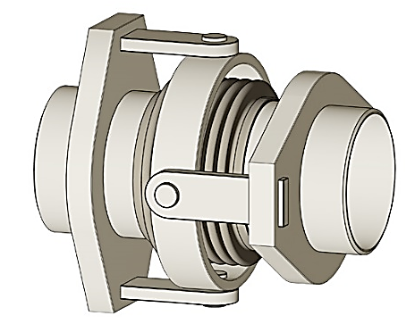
These expansion joints are made of a single bellows element equipped with two pairs of hinges affixed to a common floating Gimbal ring. Gimbal Bellows construction, designed to absorb Angular movement (Multi Plane) of the pipe section in which it is installed according to operated pressure of a device. Normally, Gimbals are designed to resist pressure thrust. This model is manufactured with butt weld connection, Fixed Flange, Loose flange, with sleeve or without sleeve
Manufacturing Range
DN 100………. DN 3200
(4”…….128”)

Temperature
800 Deg.C (1472 Deg.F)

Pressure
40 bar.g
(Above 40 bar.g also possible upon request)
Gimbal EXPANSION JOINT
The Gimbal Expansion joints are prepared with two pairs of hinges affixed to a common floating Gimbal ring, to absorb Angular rotation in Multiplane. The Gimbal are normally designed to resist pipe thrust Pressure.
Gimbal expansion joints can be supplied with all kinds of end connections, such as weld ends, fixed flanges & loose flanges.
APPLICATION
Gimbal Expansion Joint is particularly well adapted to the absorption of Angular movement in Multiplane. In addition, the Gimbals are designed to resist the pressure thrust from the piping system.
They are extensively used in irregular and complex pipe systems, hot piping systems, that include Engines, Steel mills, Petro Chemical Plants, Power Generation, Shipbuilding industry, Water treatment, Cement plants, and Paper industry .even if the movements are complex and in several planes.
They can accommodate very large movements with very low reaction forces, without need of fixed points. In addition to support, the dead weight loads from the nearby pipes and equipment.
Accessories & item description
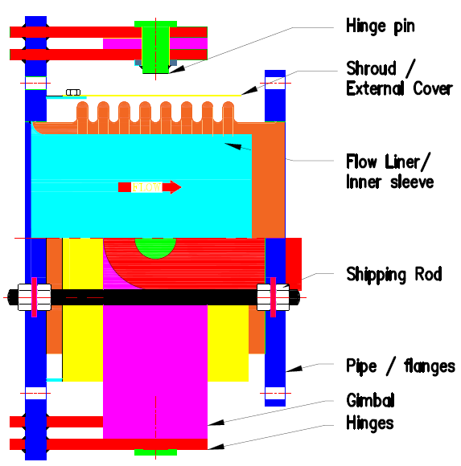
External Cover / shroud
Used to protect the expansion joint.

Flow Liner / Inner sleeve
Protects bellows from erosion damage due to abrasive media or turbulent flow.

Hinge Plate
Hinges are used to limit axial movement and to achieve angular rotation of a Multiplane.

Gimbal ring
Consisting of two or multi-pivoted rings at right angles to each other, that provides free suspension in all planes.

Hinge Pin
Enabling rotational movement between two parts while maintaining alignment.

Shipping Rod
Rigid support devices to maintain the overall length of the assembly for shipment.
End Pipe / Flange
Used to mount the pipeline. By using bolting / welding.

Advantages / characteristics

- Absorbs angular movements in all planes and angular rotations, or any combinations of these
- More flexible than a hinged expansion joints
- Eliminates main anchors
- Supports dead weight of the intermediate piping.
- Eliminates pressure thrust loads.
- Simple solution for irregular and complex pipe systems.
- Accommodate very large movements with very low reaction force.
- Use normal guides
- Absorbs angular movements in muli plane.
- Corrosion resistance.
- Temperature resistance.
- Leak tightness.
- Pressure resistance.
- Mechanical strength.
- Fatigue strength
- Freedom from maintenance.
- Prevents torsion on the bellows elements

requirements
- Changes in flow direction is required.
- More space consuming than axial expansion joint.
- Two or three expansion joints are required for a system
FEATURES
- Gimbal expansion joints for general pressure application.
- Permits angular movements in any plan.
- Eliminates pressure thrust load
- Prevents torsion or twisting of the expansion joint.
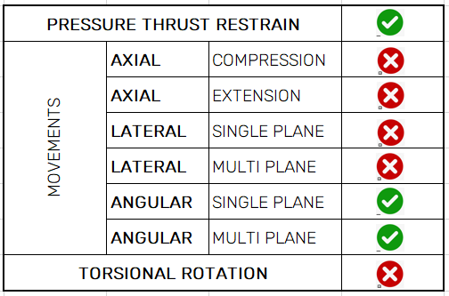
- Transmits shear and wind loads, so low forces on the pipe anchors.

